Area 26 October Assembly

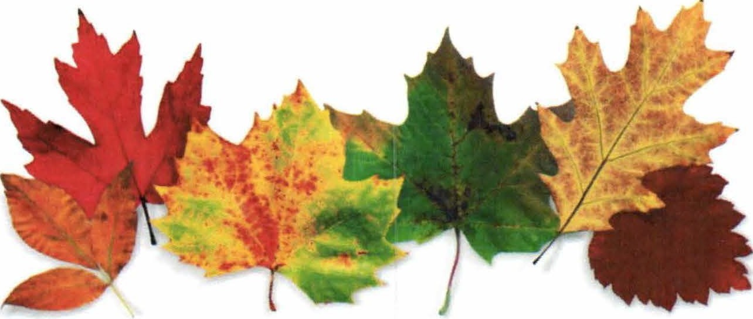

October 20-21, 2018

Hosted by Districts 15,28,14,20,&32
General Butler State Park

1608 Ky 227 Carrollton, Ky 41008

Lodge rooms: $145+taxes Reservations: 502-732-4384
Host hotel: Hampton Inn $98+taxes Reservations 502-732-0700
Mention Area 26 for this pricing!!!! Must reserve by September 19th.
Other hotels in same area as Hampton
Holiday Day Inn Express 502-732-6770
Red Roof Inn 502-732-7027
Super 8 502-414-1910

Speaker meeting Friday and Saturday night 8:00

Lunch provided on Saturday

For questions contact:

Timothy McG. 859-420-3293 Anthony B. 859-699-0964

